**SEMI Annual**

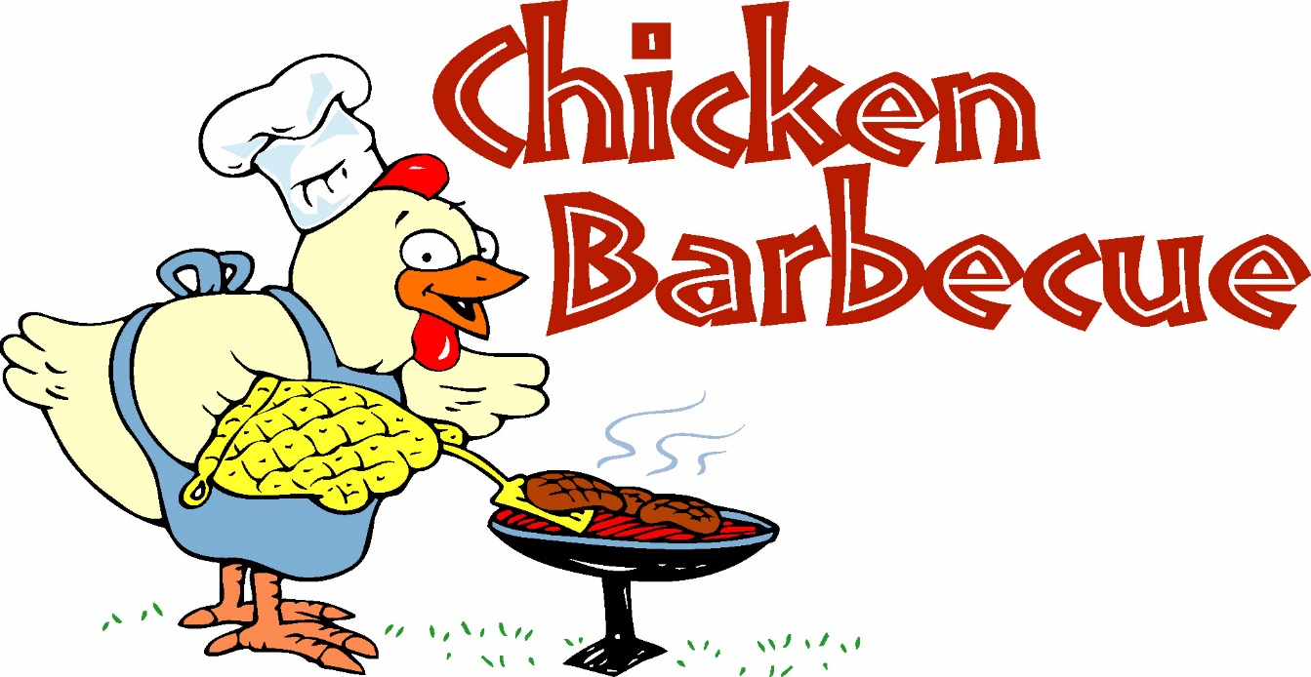

Saturday, September 28th

12 PM-Sell Out

$10.00/platter

***Soul Cafe, a United Methodist Faith Community doing church differently!***

300 E Evesham Ave. 260 Erial Rd.

Magnolia, NJ 08049 Pine Hill, NJ 08021

856-739-1052 856-435-8503

[soulcafenj@yahoo.com](mailto:soulcafenj@yahoo.com)

www.soulcafenj.com

Thank you for your support!

**Pre-orders encouraged – (856) 739-1052 or (856) 435-8503**. You can also donate a platter to the homeless. We will take all donated platters to Camden and the train stations in SJ to drop off Saturday evening. *For an extra $1 you can add a dessert and drink.* ***Pick up and delivery (at least 5 orders prepaid up to 7 miles). We are located @ 300 E Evesham, Magnolia (red brick building behind Royal Farms, just follow the smell of the BBQ!)*** *ALL proceeds will go towards the ministries of Soul Cafe.*

**Platter includes:**

**¼ Chicken and 2 sides**

*(choice of Mac n Cheese, Green Beans, Garden Salad, and Collard Greens)*