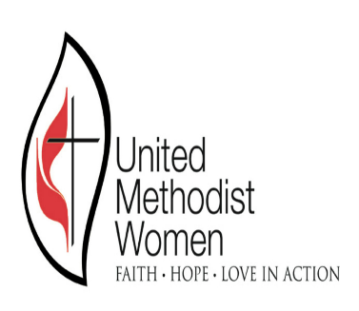

***Gateway South United* *Methodist Women***

Mission “U” Mini School

**Human Trafficking**

**“Our Children are not for Sale”**

**Saturday, March 16, 2019**

**9:00 am – 12:00**

**Guest Speakers**

Rev. Gwendolyn Cook

& Kathryn Gaines- Mathis

WWITS Youth Mentoring Program

**St. Johns United Methodist Church**

410 Fairview Street

West Berlin, New Jersey 08091

Continental Breakfast First Timers - Gifts

Information for New Officers Book List for Mission “U”

News Letters & Websites Church Recognition