Dear Brothers and Sisters in Christ,

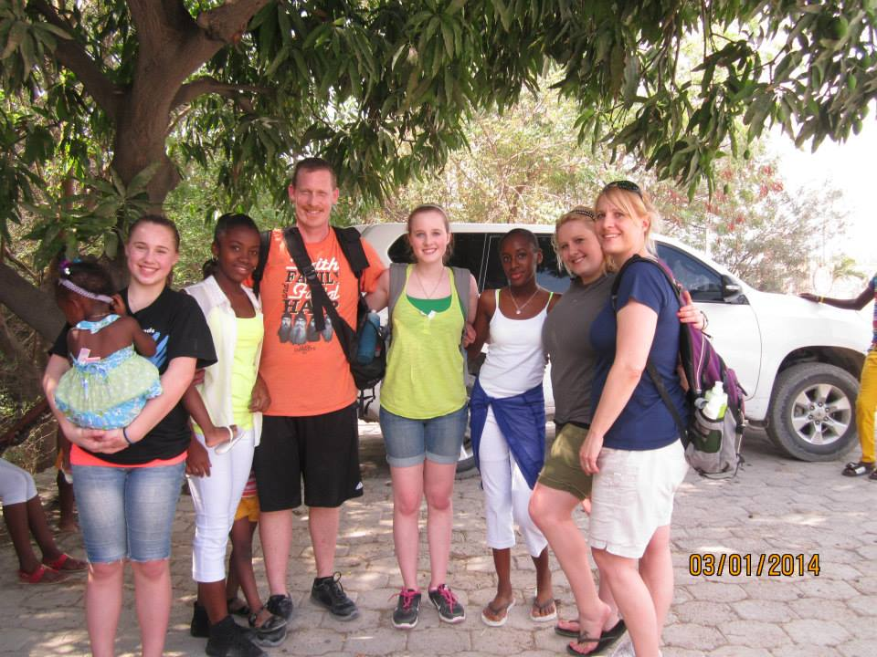We hope this letter finds you in joy and good health. Please let me introduce my family and myself. We are the Van Mater family from Sewell, NJ in Gloucester County. We have been members of St. John’s UMC in Turnersville for over 10 years and have been a very active part of the congregation through Children’s Ministry, Youth Ministry, food ministry, and most recently, the Missions team.

We have served as part time missionaries in Haiti since 2012 at Greater Works Home for Girls in Delmas (a suburb of Port Au Prince). In 2015, we founded our own charity “Our Faithful Provisions” that has provided over 42,000 meals to the children and families of Cite Soleil, Haiti. We provided the funds to replace roofs on homes and the community church after Hurricane Matthew hit. We sent money to our partners in Cite Soleil to hold VBS and a medical clinic in Jeremie -one of the coastal towns completely obliterated by the Hurricane- in July following the storm. During VBS, 30 Haitians dedicated their lives to Christ! OFP has held Christmas parties for the past 2 years for the children of De’Ecole Miste la Redemption School in Cite Soleil which included a hot meal with fresh fruit and juice, a toy, and bibles and cross necklaces for each child.

With the recent turmoil in Haiti as a result of corruption in the government, a decrease in the value of the currency, and a major increase in inflation, the Haitian people are forced to live without the most basic necessities such as toothpaste, deodorant, and feminine hygiene products. For example a box of Corn Flakes is currently $18 US dollars. Basic wounds go untreated and lead to devastating effects and disabilities. Children die because of a lack of fever reducing medications and the inability to seek medical attention.

In July of this year, we will be leading a team of 16 men and women from St. John’s back to Haiti to hold VBS for 225 of the local children in Delmas. It is our goal to send each child home with a bag of food containing 28 meals, a soccer ball, and medical and hygiene supplies.

We are reaching out to our fellow believers in the hopes that many if not all of the items can be collected since our monetary resources are extremely limited. We would humbly ask if your church would be willing to place a collection box in an area that most people would see it so that they could simply drop in any needed items. We will then collect the boxes from you whenever they are full or you would like them removed. Below is a list of the items we would like to have donated. If you are able to help us, please let us know via email at [jvanmater@comcast.net](mailto:jvanmater@comcast.net) or by calling 856-582-5148 (please leave message). You can also contact St. John’s UMC at 856-227-6567.

ANTACIDS FABRIC BAND AIDS ALL SIZES NEOSPORIN OINTMENT OR GENERIC

DEODORANT FEMININE HYGENE PRODUCTS MEDIUM TUBES TOOTHPASTE

JUNIOR STRENGTH ACETOMINOPHEN

Thank you and may God bless you immensely,

Jim, Margie, Jessica, Erika, and Katelyn (KC) Van Mater

77 Borrelly Blvd

Sewell, NJ 08080