**Clergy Leadership Development Seminar**

**Agenda for November 14th**

9am – Gathering Time with Coffee and Refreshments

9:30am – Worship

10:30am –The Big Idea

* How does focusing on one big idea impact your worship service?
* What do you need to do to begin long term worship planning?

10:45am – Crafting a Sermon Series *(outline found on pages 4-7)*

* 7 Week Sermon Series: “Questions We Ask God”
* The big idea of the Series – “We meet God in questions… not just the answers.”
* Summary - Questioning takes courage. It’s the way that we learn and the way we grow. When we ask God questions we keep the conversation with God going. Through stories of people who were seeking and questioning we learn of the in-breaking of God’s grace and love. This Lent, rediscover your curiosity and meet God in the questions… not just the answers.
* Big Group Brainstorming
* “What questions do you ask God?”
* Of our listed questions, which ones pertain to Palm Sunday and Easter?
* These questions will be weeks 6 and 7 of the series.
* Discern 5 questions to be weeks of 1 – 5 for the series.

11:45am – Crafting a Week of a Series *(outline found on pages 8-10)*

* Example
* Title: “Why do bad things happen to good people?”
* Scripture: Acts 7:54 – 60, The Stoning of Stephen
* The big idea of the week – The world does not always reward faithfulness
* In groups each table will brainstorm one week of our Lenten Series.
* For our Lenten Series, develop for the week
* The big idea
* The scripture
* Opening story, question or illustration
* Two or three points you will cover in the sermon
* Action step the congregation can take to live out the big idea of the week
* Music selections
* As you develop a week of the series, please assign a scribe who can submit your group’s notes at the end of today. Then each week’s series will be complied made available to the entire team.
* What is the right order to put these questions in for an effective sermon series?

12:30pm – Lunch

1pm – Review the GNJ Leadership Expectations

* In your congregation, where have you witnessed growth in one of the below areas? In what way did your leadership contribute to the growth? How did this change connect with the community?
* Boundless Hope
* Passionate Faith
* Courageous Mission
* Transformational Leaders
* Vital Congregations
* Regenerative Resources
* What is one other area that you are working on?

1:30pm – Emotional Intelligence in Small Group Dynamics *(see page 13)*

* Purpose of this activity is for the pastor to help facilitate resonant leadership in a group dynamic.
* One person in the group to be the “pastor”
* Select one of the four scenarios.
* The group spends 5 minutes reading the scenario and discussing various approaches.
* The “pastor” and the group role play the scenario.
* There is a two minute feedback session.
* In the feedback session consider:
* Which of the four dimensions of emotional intelligence was displayed?

1. Self-awareness – emotional awareness, accurate self-appraisal, self-confidence
2. Social Awareness – empathy, organizational awareness, service-orientation
3. Self-Management – initiative, transparency, adaptability, emotional self-control, optimism/conscientiousness, achievement
4. Relationship Management – inspiration, influence/communication, developing others, teamwork and collaboration, change catalyst, conflict management

* What type of leadership style was exhibited?
  + Commanding, Visionary, Affiliative, Democratic, Pacesetting, Coaching
* Were any of the “three basic rules to trigger change” experienced?

3 Basic Rules to Trigger Change – Chapter 10, *Primal Leadership*

1. Focus people’s attention on the underlying issue and solution to create a common ground and understanding about what needs to change and why.
2. Focus on the idea, combining resonance-building leadership styles to get people talking about their hopes for the future and tap into the dedication people feel for the organization.
3. Move from talk to action. This starts with the leader. Bringing people together around a dream, moving from talk to action, and modeling new behaviors.

2:30pm – Resourcing for December 19th

**Sermon Series Planning Template (Sample)**

**Series Title:** At the Movies!

**Big Idea:** The truths of God are present everywhere

**Felt Need:** This summer we need to have fun and engage our culture

**Series Summary/Description:** In August 2017 we will preach on this summer’s blockbuster movies. Selecting one major motion picture each week we will observe truths about God and the messages that culture is relating.

Week 1 Date/Title August 6 Wonder Woman

Week 1 Scripture Genesis 1:26-27

Week 1 Big Idea All people are created in God’s image and called “good.”

Week 2 Date, Title

Week 2 Scripture(s)

Week 2 Big Idea

Week 3 Date, Title

Week 3 Scripture(s)

Week 3 Big Idea

Week 4 Date, Title

Week 4 Scripture(s)

Week 4 Big Idea

**Sermon Series Planning Template**

Series Title

Big Idea

Felt Need

Series Summary/Description

Week 1 Date, Title

Week 1 Scripture(s)

Week 1 Big Idea

Week 2 Date, Title

Week 2 Scripture(s)

Week 2 Big Idea

Week 3 Date, Title

Week 3 Scripture(s)

Week 3 Big Idea

Week 4 Date, Title

Week 4 Scripture(s)

Week 4 Big Idea

**Weekly Sermon Series Template (Sample 1)**

**Series Title:** At the Movies

**Big Idea:** The truths of God are present everywhere

**Series Part:** *(Week 2 of 4)*

**Week Title:** Wonder Woman

**Week Scripture:** Genesis 1:26-27

**Week Big Idea:** All people are created in God’s image and called “good.”

**Opening (Could be a story, question or illustration):** I was driving this week and someone cut me off in traffic. You know, I was running late and really annoyed. I may have demonstrated an inappropriate finger gesture. The worst part was that down the road we were both stopped at a red light; I pulled up right next to him! You know what he did? He waved at me. Not a sarcastic or mean wave either, just a cordial, friendly wave. While we all have our moments, maybe we aren’t all bad.

**2-3 Points:**

1. Like Wonder Woman, we all have moments when we doubt the goodness of humanity.
2. All of us are created in the image of God.
3. The people who make us the most angry probably need Jesus the most.

**Action Step:** This week, you’re going to have one or two interactions with people that make you so mad! In that moment, take a deep breath. Remember that the other person is created in the image of God. Find some way to love them. You may be the only glimpse of Jesus that they see this week.

**Music ideas:**

Make Me a Captive, Lord UMH #421

No Longer Slaves Bethel Music

Weekly Checklist:

* Worship resonates with thinkers, feelers and doers.
* Worship honors all cultures in our community.
* Worship uses a local story or illustration.
* There is a celebration of life transformation present in the service.
* Service is aligned around one Big Idea.
* Every week is someone’s first week.

**Weekly Sermon Series Template**

**Series Title**

**Big Idea**

**Series – Week ___**

**Week Title**

**Week Scripture**

**Week Big Idea**

**Opening (Could be a story, question or illustration)**

**2-3 Points**

**Action Step**

**Music ideas**

**Weekly Checklist:**

* Worship resonates with thinkers, feelers and doers.
* Worship honors all cultures in our community.
* Worship uses a local story or illustration.
* There is a celebration of life transformation present in the service.
* Service is aligned around one Big Idea.
* Every week is someone’s first week.

**GNJ Leadership Expectations**

GNJ leaders stir up, anchor and release boundless hope, passionate faith, courageous mission, transformational leaders, vital congregations, and regenerative resources.

1. *Boundless* Hope – **Positive vision** of current and future ministry

* Bible passage – “Very truly, I tell you, the one who believes in me will also do the works that I do and, in fact, will do greater works than these, because I am going to the Father.” – John 14:12
* Question – Does the congregation have a hopeful view of its future?

1. *Passionate* Faith – **Fearless disciples** that others want to emulate

* Bible passage – “Now when they saw the boldness of Peter and John and realized that they were uneducated and ordinary men, they were amazed and recognized them as companions of Jesus.” – Acts 4:13
* Question – Do the people of the congregation have an enthusiasm for following Jesus Christ and are committed to the church and serving others?

1. *Courageous* Mission – **Risk-taking community connection** and engagement

* Bible passage – “But you will receive power when the Holy Spirit has come upon you; and you will be my witnesses in Jerusalem, in all Judea and Samaria, and to the ends of the earth.” ­– Acts 1:8
* Question – Do people in the community believe and experience the congregation’s mission as bold and courageous? Do they experience the radical love of Jesus in the congregation’s mission and ministry?

1. *Transformational* Leaders – **Difference makers** in people’s lives, the congregation and the community

* Bible passage – “For if you keep silence at such a time as this, relief and deliverance will rise for the Jews from another quarter… Perhaps you have come to royal dignity for just such a time as this.” – Esther 4:14
* Question - Are the leaders of your congregation making a significant difference through their leadership? Do the leaders work with all members of the congregation and relate well with the community?

*(continued)*

1. *Vital* Congregations – **Indispensable ministry** with people and the community

* Bible passage - “All who believed were together and had all things in common; they would sell their possessions and goods and distribute the proceedsto all, as any had need.Day by day, as they spent much time together in the temple, they broke bread at homeand ate their food with glad and generoushearts, praising God and having the goodwill of all the people. And day by day the Lord added to their number those who were being saved.” – Acts 2:44-47
* Question – Are people in the community drawn to participate in your worship, small groups and ministry?

1. *Regenerative* Resources – **Cultivate generosity** to increase mission

* Bible passage – “The point is this: the one who sows sparingly will also reap sparingly, and the one who sows bountifully will also reap bountifully. Each of you must give as you have made up your mind, not reluctantly or under compulsion, for God loves a cheerful giver. And God is able to provide you with every blessing in abundance, so that by always having enough of everything, you may share abundantly in every good work.” – 2 Corinthians 9:6-8
* Is your congregation achieving its full potential financially in order to bless God and others?

**Emotional Intelligence in Small Group Dynamics**

1. The pastor is about to enter the SPRC meeting. The pastor does not realize that the majority of the SPRC members have already decided not to recommend a raise for the staff and pastor for 2018. A majority of the members of the committee met in the parking lot after church on Sunday and made this decision. This decision of not recommending a raise elicits mix results from the group. Some people feel the pastor should have been included in this group decision. A member of the committee greets the pastor with the news “This meeting will not be long tonight, because the Staff Parish decided we cannot afford to give raises for the staff this year.” How will the pastor respond to the group?
2. The pastor is about to enter a trustee meeting. At the last meeting it was decided that the trustees would support the worship committee’s request to purchase and install a projector and screen in the sanctuary. Two members of the trustees believe this is good decision. Another member of the committee believes the money could be used in a better way. A member of the committee greets the pastor with the news, “I know we decided on installing a projector in the sanctuary at our last trustee meeting, but I am not so sure if that was a good decision.” How will the pastor respond to the group?
3. The pastor is about to enter a confirmation class meeting. The youth all have reasons about why they cannot make next month’s confirmation meeting. Someone from the group greets the pastor with the news, “Pastor, I cannot attend confirmation class next month because…..” During the discussion it is revealed that the next meeting was scheduled on Super Bowl Sunday and that is why the kids do not want to attend. How will the pastor respond to the group?
4. The pastor is about to enter a church council meeting. It is the month of April and the church will become a two point charge in July 1st. Both churches have worship at 10am. A council member brings up the point that the church may need to change their worship time. Spirited discussion ensues. Someone from the group begins the discussion by saying, “I know that you will have a two point charge this July, how do you think it will affect our worship time?” How will the pastor respond to the group?

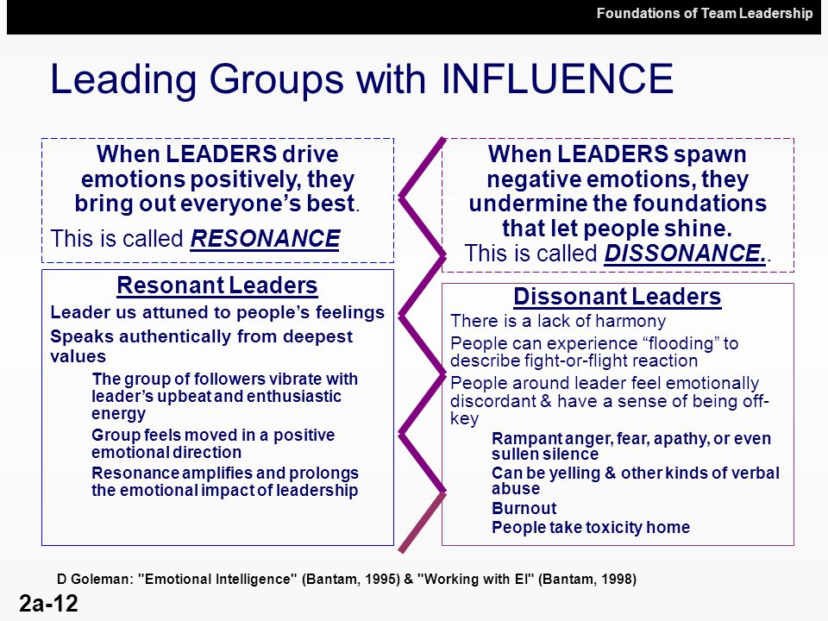

**Clergy Leadership Development Seminar**

**Resourcing for 12.19. 2017**

1. Read chapter 2 of *The Big Idea: Focus the Message – Multiply the Impact* by Dave Ferguson.
2. Review resource from Discipleship Ministries, “How to Start Small Groups: Growing Larger by Acting Smaller.” Your computer might ask you “Is the link from a trusted source?” Yes, it is, as it is from the Discipleship Ministries page.

<https://gbod-assets.s3.amazonaws.com/legacy/kintera-files/about-gbod/AC_SmallGroups_Digital.pdf>

1. Read the following article: <http://www.lifeway.com/Article/Relationships-the-glue-that-holds-your-church-together>
2. Based on one week of our Lenten Worship Series, prepare a statement and a three questions that will start a discussion in a small group you will lead this Lent. ***Remember, sharing and connecting in your Lenten small group is just as important as the content being taught.