**Clergy Leadership Development Seminar**

**Agenda for October 24th**

9am – Gathering Time with Coffee and Refreshments

9:30am – Worship

10:30am - Review the 4 types of leadership styles

* What style of leadership do you most often use: the commanding, visionary, affiliative, democratic, pace setting or coaching?
* Share about a time when you used one of the styles above and how was it received?

10:45am – SMART Goals

* Review Smart Goals
* Check-in on goals
* Specific, Measurable, Attainable/Actionable, Relevant/Results Orientated, Timely
* <http://www.umcom.org/learn/critical-components-of-smart-church-goals>

Three phases of the goal process  
*1. Set goals.*  
Our goals should be aligned with the mission we are called to accomplish.

*2. Take action.*  
Identify specific actions that need to be taken to reach the larger goal.

*3. Evaluate goals.*  
Measure the results. How will you know if the goal has been achieved? The clearer your goals, the easier they are to evaluate. Ask, “What did I do well?” and “What can I do differently in the future?”

* “Worship Goal: First UMC will improve the quality of the audio-visual experience of worship by having 4 additional people trained to do the lights, sound board, and run the worship media before March 15 so as to properly staff Holy Week/Easter Services. Part of the sound board training will be led by a sound board engineer from The Music Den.”
* Is this a SMART goal?
* What specific actions need to be taken?
* How will you know you have achieved this goal?
* Review your Smart goals, name what specific actions needs to be taken, and how will you evaluate if you have achieved this goal.

11:15am – Personal Application

* What is the ideal self and real self?
* Spend 10 minutes completing the Boyatzis’s Theory of Self Directed Learning Worksheet.
* In pairs, share your responses. Be an active listener. Consider statements such as:
* “I really like…”
* “Share with me more why you see that is important.”
* “Tell me more about that.”
* “I am curious about…”

12noon – Lunch

12:30pm –Reflect on Boyatzis’s Theory of Self Directed Learning Experience Worksheet

12:45pm – Unpacking the 3 Questions

* In table conversation, how do these questions assist you in evaluating a worship service?
* Why do you do what you do *in worship*?
* What do new people think *when they experience your worship*?
* What is being celebrated *in worship*?
* Review of Bulletins and Worship
* Referring to one bulletin and one sermon at a time, use the three questions to evaluate your order of worship, music selection and sermon for a service.

1:45pm – Application

* In self-selected groups, how would you design a service for Stewardship Sunday, Thanksgiving Sunday, Christmas Eve, New Year’s Eve, or Ash Wednesday by answering the three questions? Use poster paper to write your responses.
* What would you do in the worship service to reflect your theme and why?
* What do you want to communicate about your theme to new people?
* What will you celebrate about your theme, and how will you celebrate it?
* Group Discussion: How can you use these three questions in your local church?

2:45pm – Resourcing for November 14th

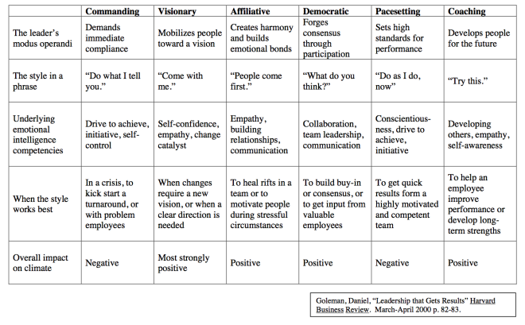

**October 24, 2017 - Emotional Intelligence**

**Primal Leadership**

**Boyatzis’s Theory of Self-Directed Learning**

**First Discovery: My ideal Self**

*I want to be…*

**Second Discovery: My Real Self**

*Who am I really?*

What are my strengths, where my ideal self and real self overlap?

What are my gaps, where my ideal self and real self differ?

**The Third Discovery: My Learning Agenda**

I can build on my strengths by….

I can reduce my gaps by….

**The Fourth Discovery: Experimenting with and practicing new behaviors, thoughts, and feelings to point of mastery.**

What new behaviors, thoughts and feelings will I embrace to grow closer to my ideal self?

**The Fifth Discovery: Developing Relations**

I will develop supportive and trusting relationships with whom and by doing what?

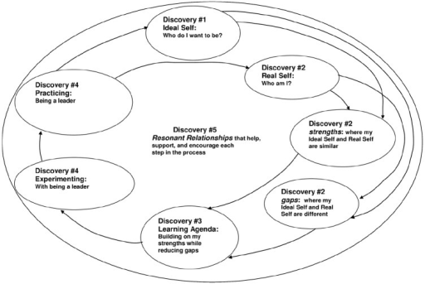

**Clergy Leadership Development Seminar**

**Resourcing for 11.14.17**

1. Read chapters 9 - 11 of [Primal Leadership](http://www.amazon.com/gp/product/1422168034/ref=as_li_tl?ie=UTF8&camp=1789&creative=390957&creativeASIN=1422168034&linkCode=as2&tag=leawelnet-20&linkId=PPJ4TFZAGIDKCSHP) by Daniel Goleman, Richard Boyatzis, and Annie McKee.
2. Review resourcing guide for Primal Leadership and prepare for conversation.
3. Read chapter 6 and 7 of The Big Idea: Focus the Message – Multiply the Impact by Dave Ferguson.
4. At our November meeting we will be developing a Lenten Sermon Series as a team. In preparation for our meeting, review sermon series “After the Disaster” published by Discipleship Ministries last year. The link to the series overview is: <https://www.umcdiscipleship.org/resources/after-the-disaster-jeremiah-and-minor-prophets-intro>

At the bottom of the page, click on preaching notes for weeks 1 through 7 that are highlighted in red and review the content. In preparation for developing a group Lenten Sermon Series at our next gathering, consider:

* What makes a good sermon series?
* What is the purpose of Lent?
* Why would one choose to develop a Lenten Sermon Series?
* Based on the purpose of Lent, what themes would support a Lenten Sermon Series?
* What do you want new people to think who visit your church during Lent?
* What should be remembered or celebrated in worship during Lent?

***Primal Leadership – Part III***

**Reading Guide for 11.14.17**

As you read chapters 9 – 11 of *Primal Leadership* consider the following questions. *You will be responsible for sharing answers to the content questions in small groups.*

**Chapter 9:  The Emotional Reality of Teams**

*Content Questions*

* How is the development process different for a team and individual? Do you agree? Why or why not?
* How can a team’s emotional intelligence impact its overall effectiveness?

*Personal Reflection*

* When was a time you had to lead change? What techniques worked effectively? What would you do differently today?
* What are some spoken or unspoken norms in your congregation? These norms may be positive or negative. How are you being a resonant leader amidst these norms?

**Chapter 10: Reality and the Ideal Vision**

*Content Questions*

* What is the difference between attunement and alignment?
* What does discovering the emotional reality, visualizing the ideal and sustaining emotional intelligence have to do with change?

*Personal Reflection*

* What is the reality of the mission and vision of your congregation? What do you sense is God’s ideal vision for the church? How does this compare with the church leadership’s vision of the church? What do you see are your next steps?

**Chapter 11: Creating Sustainable Change**

*Content Questions*

* What happens if you do not respect culture? What challenges can that present to a change effort?
* What are your reactions to the premise "succeed with a process, not a program"?
* What overall impact can being a resonant leader make on an organization?

*Personal Reflection*

* Define emotional intelligence.
* What area of emotional intelligence could be your focused area of growth? Is it growing in leadership competencies? Experimenting with a new leadership style? Developing a learning plan based on your strengths and gaps? Sharing the reality of a program success with leadership? Casting a vision? Cultivating change in a group? Something else?
* What is the next step you can take in your focused area of growth?