**Clergy Leadership Development Seminar**

**Agenda for September 26th**

9am – Gathering Time with Coffee and Refreshments

9:30am – Worship

10:30am – Review Covenant

10:45am – Review Thinkers, Doers and Feelers

* Share with your table one way you tried to better understand and connect with those in your congregation or community who are
* Thinkers
* Doers
* Feelers

11:00am – Primal Leadership

* In groups of 4, each person will review one of the chapters and teach their group the main learnings.
* As you discuss chapter 4, review the four types of positive leadership styles
  + Discuss the style of leadership you most use.
  + What is the strength of your style?
  + What is the limitation of your style?
  + What style do you find the hardest to work with and when do you notice it most?
  + What do you need to know about how other people engage/lead to work with them effectively?
  + What is one thing you value about each of the other styles?

11:30am – Application

* There are four quadrants of the emotional intelligence leadership competencies, consisting of a total of 18 leadership skills.
* What emotional intelligence leadership competency or skill is your strongest? Share a time when you used this competency or skill effectively.
* Share a time you failed in your leadership. What emotional intelligence leadership competency or skill could you have used, and how might it have changed the outcome?

12noon – Fish Bowl

* The goal of this exercise is to apply the emotional intelligence leadership competencies and their skills. There are four quadrants of the emotional intelligence leadership competencies consisting of 18 leadership skills.
* Each team will consist of three people: pastor, congregant and observer. Each round will be 8 minutes. Select a discussion topic. Take 1 minute for the pastor and congregant to think about the situation and how you would respond. Spend five minutes in the situational discussion, then two minutes for the observers and congregant to give feedback.
* The observer will be listening to note that 3 - 5 of the emotional intelligence leadership competencies are exhibited by the pastor.

12:30pm – Lunch

1:00pm – Smart Goals

* Review the definition of a SMART Goal
* In groups of four, each person will have an opportunity to share their SMART goals.
* After each goal is shared the group will provide feedback.

1. Is the goal a SMART Goal?
2. Which GNJ leadership expectations are reflected in the church focused SMART Goals?

* Boundless Hope
* Passionate Faith
* Courageous Mission
* Transformational Leaders
* Vital Congregations
* Regenerative Resources
* Each person shares one SMART Goals with the large group

2:30pm – Resourcing for October 24th – See “Resourcing” worksheet for more information

* SMART Goals
* Primal Leadership Chapters 5 - 8
* The Big Idea Chapters 1, 4, 5
* Worship bulletins and sermon summaries for 3 services

**Covenant for 2017-2018 Clergy Leadership Development Seminar**

1. The Purpose: The GNJ Clergy Leadership Development Initiative is designed to develop pastoral leaders who excel in fruitfulness and grow vital congregations.  Fruitful leadership means:

* Leading a congregation to vitality
* Developing and growing lay leadership
* Building connections and relations well with the church leadership, members and community residents
* Leading the congregation to deeper faith and service in the world, and
* Raising sufficient funds for salary and benefits, shared ministries, ongoing congregational ministry and community and world mission

1. We will meet for 12 months, after which we will evaluate our direction.
2. We will gather one Tuesday a month from 9:30am - 3pm at the Mission Resource Center unless otherwise prearranged. September 26, October 24, November 14, December 19, January 23, February 27, March 13, April 17, May 8, June 19, July 17.
3. We will agree to the following primary values for our group:

Participation: *What do you expect of yourself, your colleagues and the facilitators in preparation for our gathering and when we gather?*

* Willingness to be engaged
  + Openness to new ideas
  + Non-judgmental
  + Receptive to feedback
  + Respectful
* Allowing for a pause before feedback - Selah
* Thorough Preparation
  + Complete readings
  + Arrive on time
  + Stay to the end
  + Plan your schedule around the seminar dates
  + Have a back-up for emergencies

Confidentiality: *What do we hold in confidence within the group, so that we can encourage people to speak openly? What can we share with others outside prayer the group about our time together?*

* Our Core Value is Trust
* As a group we agree to
  + Only share generalities of the program
  + No personal information or details shared outside those participating in the seminar
* Discretion among group members

Growth and Development (action orientated): *What commitments will we make for the fruitful growth of ourselves and for the group as a whole? How can we provide helpful feedback in a positive way so that growth and development occur?*

* Continually preparing for sessions - no cramming
* Having and being determined to trust that enables sharing the good, the bad and the ugly
* Mutual prayer with a roster of participants
* Self-care
* To encourage and give informative feedback
* Allow for processing time during learning sessions

Relationship Building: *What will we do to foster positive and supportive relationships within the group so that trust is built?*

* Fostering Engagement more than monthly
* Create a private Facebook Page “CDLI – Team One”
* Fully present with no distractions
* Know each other beyond “work” interests
* Be intentional about having lunch with those outside of your comfort zone

**Emotional Intelligence**

**Topics for Fish Bowl Discussion 9.26.17**

1. Someone in the greeting line after church says to you, “My daughter is sick in the hospital, I left you a message and you have not gone to visit her. I am disappointed.” How do you respond?
2. A member makes an appointment to meet you in the office and says, “I have a great idea that could help us connect with the community. I would like to lead an afterschool program starting October 15th.” How do you respond?
3. It is three weeks before VBS and your VBS coordinator sends you a text message that she is overwhelmed, feels unsupported by you and is going to have to step down from leading VBS. What do you next?
4. You recently moved to a new church and your parsonage has inadequate furnishings and the non-working lawn mower. You are speaking to the SPRC chair who is also a member of the trustees. How does the conversation unfold?
5. You have been at a congregation for a few months and learn that the offering counters are a married couple, who are long time members, who take the money home to count and deposit the money on Monday or Tuesday. You are meeting with the lay leader of the church. What happens next?
6. A new member of your church plays guitar and has a great singing voice. He says during fellowship hour, “Pastor, I would love to play some Sunday in worship. Actually I have a few worship songs from the radio I have been practicing. Could I play some of my songs in the next few weeks?” Your church has a very traditional worship service that has experienced very few changes in the last few years. What do you say next?

**Clergy Leadership Development Seminar**

**Resourcing for 10.24. 2017**

1. During the next month review your SMART Goals with your District Superintendent and with members of your Pastor Parish Relationship Committee. Receive feedback and continue to refine your goals. Bring a printed copy of your goals to our October gathering, as we will bless them during our worship service. Please submit a copy of your goals at the gathering. This will help ensure that our seminar objectives and learnings resource the SMART Goals.
2. Read chapters 5 - 8 of [Primal Leadership](http://www.amazon.com/gp/product/1422168034/ref=as_li_tl?ie=UTF8&camp=1789&creative=390957&creativeASIN=1422168034&linkCode=as2&tag=leawelnet-20&linkId=PPJ4TFZAGIDKCSHP) by Daniel Goleman, Richard Boyatzis, and Annie McKee.
3. Review resourcing guide for Primal Leadership and prepare for teaching and conversation.
4. Read chapter 1, 4 and 5 of The Big Idea: Focus the Message – Multiply the Impact by Dave Ferguson.
5. Bring three printed bulletins and sermon summaries. Sermon summaries are for you to reference during our conversation and can be one paragraph in length. At our next meeting, Eric Drew, the Director of Worship, will facilitate table conversation around evaluating our worship services with three questions: “Why do we do what we do?” “What do visitors think?” and “What are we celebrating?”

***Primal Leadership – Part II***

**Reading Guide for 10.24.17**

As you read chapters 5 - 8 of *Primal Leadership* consider the following questions. *You will be responsible for sharing answers to the content questions in small groups and then presenting a summary of the chapter to the larger group.* Personal reflection questions may be shared during discussion.

**Chapter 5:  The Dissonant Styles**

*Content Questions*

* What are pacesetting and commanding styles of leadership? How can these styles create dissonance?
* Are leadership styles that create resonance better than those that create dissonance? Why are why not?

*Personal Reflection*

* Has there been a time when you have used a pacesetting or commanding style of leadership? What was the positive or negative result?

**Chapter 6: Becoming a Resonant Leader**

*Content Questions*

* What is the CEO disease? What can be its impact on an organization?
* Why should a leader have understanding of how the brain works? What impact can that make on their leadership results?
* What role does emotional intelligence play in learning?
* What is your reaction to self-directed learning? Do you agree? Why or why not?

*Personal Reflection*

* What motivates you to learn something new?
* What is the most recent skill you sought to learn? What was your motivation to do so?

**Chapter 7: The Motivation to Change**

*Content Questions*

* What does discovering the ideal self mean? Why is it an important first step towards change?
* What is the ought self?
* What does discovering the real self mean? Why is it an important second step towards change?

*Personal Reflection Questions*

* Think about where you would be sitting and reading this book if it were 15 years from now and you were living your ideal life. What kinds of people would be around you? What does your environment look and feel like? What might you be doing during a typical day or week? In what ways are you living your values? What have you accomplished? What obstacles have you overcome? How do you feel? What are three actions you can take to achieve this vision 15 years from now?

**Chapter 8: Metamorphosis**

*Content Questions*

* What is the difference between performance goals and learning goals? Which do you feel are the most effective?
* What is the advantage to building goals upon one’s strengths?
* What role does relationships play in the change and development process?

*Personal Reflection Questions*

* Which learning style do you learn most often: concrete experience, reflection, model building or trial-and-error learning?
* When was the last time you used trial-and-error learning? What was the result?
* Who was one of your greatest coaches or mentors? What did you learn from them? Who are you currently coaching or mentoring?

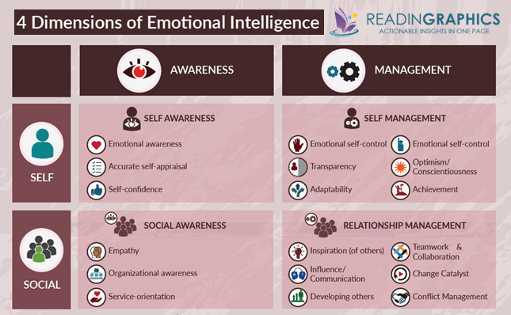

Note: In the most current edition of the book Primal Leadership, in **Self-management** quadrant, “**Emotional Self-Control” should be listed as “Initiative”**.

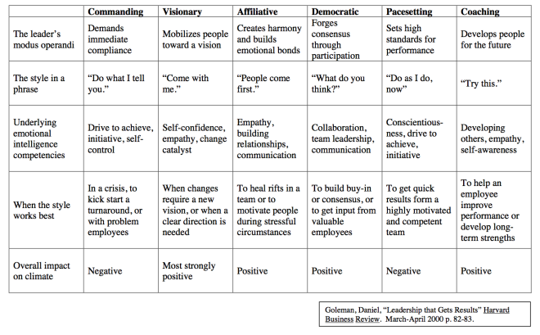

|  |  |  |
| --- | --- | --- |
|  |  | **Clergy Leadership Develop Seminar** |
| First | Last | Email |
|  |  |  |
| Jonathan | Campbell | pastorjcampbell@hotmail.com |
|  |  |  |
| Sam | Choi | choi.dr@gmail.com |
|  |  |  |
| Diane | Gilbert | RevDiMrGer@comcast.net |
|  |  |  |
| Amanda | Hemenetz | amandahemenetz@gmail.com |
|  |  |  |
| Pamela | James | [pastorpamela@optimum.net](mailto:pastorpamela@optimum.net) |
|  |  |  |
| Moses | Jarta Flomo | flomo.jarta@juno.com |
|  |  |  |
| Hillary | Johnson Crute | pastorhillary@aol.com |
|  |  |  |
| Wayne | Jones | revwaysr@msn.com |
|  |  |  |
| Sung | Lee | sungil1213@gmail.com |
|  |  |  |
| Walter | Mander | waltermander@comcast.net |
|  |  |  |
| Erik | Ostrow | E_Train777@hotmail.com |
|  |  |  |
| Sunghee | Park | sunghee.park@yahoo.com |
|  |  |  |
| Federico | Quezada | Pastorquezada@optonline.net |
|  |  |  |
| Rolando | Santiago Fuentes | pastorrolando12@gmail.com |
|  |  |  |
| Glenn | Scheyhing | gscheyhing@gmail.com |
|  |  |  |
| Don | Stevens | revdon64@hotmail.com |
|  |  |  |
| Taegun | Wang | tgwang1026@gmail.com |
|  |  |  |
| Robert | Wecht | pastorbob17@juno.com |
|  |  |  |
| Beth | Whalley Mitchell | [bethrobinmitchell@juno.com](mailto:bethrobinmitchell@juno.com) |
|  |  |  |
| Debra | Whitten | PastorDebraUV@optonline.net |
|  |  |  |
| Paul | Zorn | revzorn@optonline.net |