**Clergy Leadership Development Seminar**

**Next Cohort**

**Session 1 – September 25th**

9am – Gathering Time

9:30am – Worship with Bishop Schol Preaching

11am – Welcome

* Facilitator and Staff Introductions
* Why we are here
* Introduction to Emotional Intelligence and 4 Quadrants

11:30am – Cohort Group Gatherings

* Introductions
* Review Kolb’s idea on “How Leaders Learn Best”
* Which of the four ways do you learn best?

11:45am – Emotional Intelligence Quadrants

* There are four quadrants of emotional intelligence leadership competencies consisting of a total of 18 leadership skills.
* What emotional intelligence leadership competency or skill is your strongest? Share a time when you used this competency or skill effectively.
* Share a time you struggled as a leader. What emotional intelligence leadership competency or skill could you have used, and how might it have changed the outcome?

12:30pm – Lunch

1:15pm – Fish Bowl

* The goal of this exercise is to apply the emotional intelligence leadership competencies and their skills. There are four quadrants of the emotional intelligence leadership competencies consisting of 18 leadership skills.
* Each team will consist of three people: pastor, congregant and observer. Each round will be 8 minutes. Select a discussion topic. Take 1 minute for the pastor and congregant to think about the situation and how you would respond. Spend five minutes in the situational discussion, then two minutes for the observers and congregant to give feedback.
* The observer will be listening to note that 3 - 5 of the emotional intelligence leadership competencies that are exhibited by the pastor.

2pm – Covenant Making

2:45pm – Review the Day

3pm – Adjourn

**Kolb – How Leaders Learn Best**

Kolb said people learn best from

1. Concrete experience – Having an experience that allows leaders to see and feel what it is like
2. Reflection – Thinking about their own and others’ experiences
3. Model building – Coming up with a theory that makes sense of what they observe
4. Trial-and-error learning – Trying something out by actively experimenting with a new approach

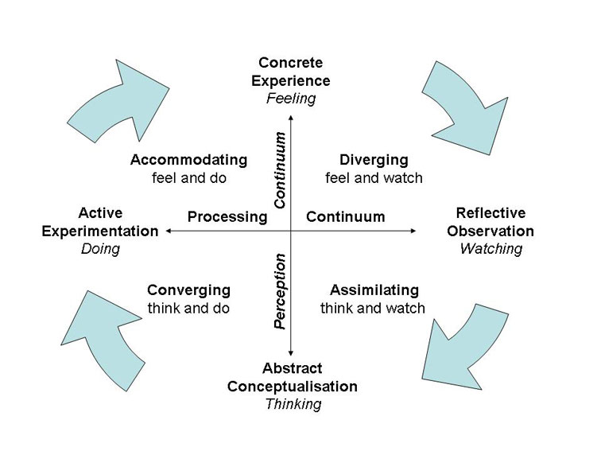

Goals

1. Goals should build on a leader’s strengths, not on weaknesses
2. Goals must be a person’s own, not goals that someone else sets
3. Plans should flexibly allow people to prepare for the future in different ways – a single planning method imposed by an organization will often prove counter productive
4. Plans must be feasible, with manageable steps and fit smoothly into a person’s life
5. Plans must suit a person’s learning style

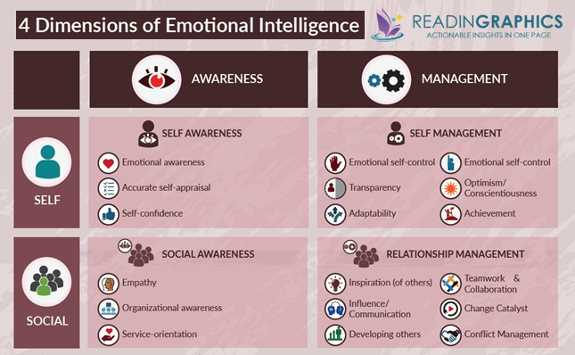

Note: In the most current edition of the book Primal Leadership, in **Self-management** quadrant, “**Emotional Self-Control” should be listed as “Initiative”**.

**Emotional Intelligence**

**Topics for Fish Bowl Discussion 9.25.17**

1. The church is in the process of establishing a care committee to visit and support members. Someone in the greeting line after church says to you, “My daughter is sick in the hospital, I left you a message and you have not gone to visit her. I know Susan from the church’s care committee visited, but I am disappointed it was not you.” How do you respond?

1. The youth minister wants to open the church gym to students on Fridays afternoons for recreation. This happens to be the same time as the UMW “Ladies Tea” Gathering. Who do you talk to next and how does that conversation go?
2. It is three weeks before VBS and your VBS coordinator sends you a text message that she is overwhelmed, feels unsupported by you and is going to have to step down from leading VBS. What do you next?
3. You recently moved to a new church and your parsonage has inadequate furnishings and a non-working lawn mower. You are speaking to the SPRC chair who is also a member of the trustees. How does the conversation unfold?
4. A congregant mentions that there is a successful after school program at a local church in the immediate area. Then asks the pastor, “When is it better to support an existing program verses starting your own?” What do you say next?
5. The organist, Joe, recently gave notice of his retirement. You feel this might be an opportunity to seek out a more diverse style of music that more likely will connect with the community. A member approaches you and says, “Pastor, I think Mary would be a great fit as organist. She fills in so faithfully when Joe is on vacation. She is a super at playing the organ and will probably even accept less of a salary for the job.” What do you say, next?
6. The church has recently created and agreed upon a vision statement. The church council chair recently led a meeting where the vision was not discussed. Conversation around the table was bogged down by building concerns and social events. How do you encourage your church council to refocus on the agreed upon vision?
7. You are a newly appointed pastor. Next week launches “Back to Sunday School.” In preparing for the event you ask the Sunday School Superintendent for a copy of the Safe Sanctuary Policy and learn there is not one in place. What happens next?
8. You are developing a new staffing position whose work will include coordinating Facebook and the website. The SPRC chair feels that this digital ministry is already being done fairly well by Mike. What happens next?

**Covenant 2018-2019**

**Clergy Leadership Development Seminar Cohort**

1. The Purpose: The GNJ Clergy Leadership Development Seminar’s Cohort is designed to develop pastoral leadership and grow vital congregations.
2. The seminar will meet for 10 months, beginning in September, after which we will evaluate our direction.
3. We will gather one Tuesday a month from 9:30am - 3pm at the Mission Resource Center unless otherwise prearranged.
4. We will agree to the following primary values for our group:

Participation: *What do you expect of yourself, your colleagues and the facilitators in preparation for our gathering and when we gather?*

Confidentiality: *What do we hold in confidence within the group, so that we can encourage people to speak openly? What can we share with others outside the group about our time together?*

Growth and Development (action orientated): *What commitments will we make for the fruitful growth of ourselves and for the group as a whole? How can we provide helpful feedback in a positive way so that growth and development occur?*

Relationship Building: *What will we do to foster positive and supportive relationships within the group so that trust is built?*

**Resourcing for October 30th**

**Next Leadership Cohort**

* By October 10th use the link to create a list of site visits that you would be interested in attending. Include the name of site, location, and how it would benefit your leadership. <https://www.gnjumc.org/urban-and-next-leadership-cohorts/>
* Read *Primal Leadership* Chapters 4, 5 and review provided reading guide.
* Bring a leadership challenge you are having in the local church to receive immediate feedback on. You will be given five minutes to explain the situation. Five minutes for the class to ask you questions. Ten minutes for the class to discuss and provide you feedback. Then five minutes for you to respond. We may not have the opportunity to share everyone’s leadership challenge in this one session.

Seminar Dates: September 25, October 30, November 27, December 18, January 15, February 5, March 12, April 9, 2019, May 14, June 11

**Reading Guide for *Primal Leadership***

**Chapters 4 - 5**

**Chapter 4: The Leadership Repertoire**

*Content Questions*

* What is your reaction to the leadership styles laid out in this chapter? Specifically, what are your thoughts about how each makes an impact on climate and when to utilize the particular style?
* How do the visionary, coaching, affiliated and democratic styles impact resonance?

*Personal Reflection*

* What style comes most naturally to you?

**Chapter 5:  The Dissonant Styles**

*Content Questions*

* What are pacesetting and commanding styles of leadership? How can these styles create dissonance?
* Are leadership styles that create resonance better than those that create dissonance? Why are why not?

*Personal Reflection*

* Has there been a time when you have used a pacesetting or commanding style of leadership? What was the positive or negative result?