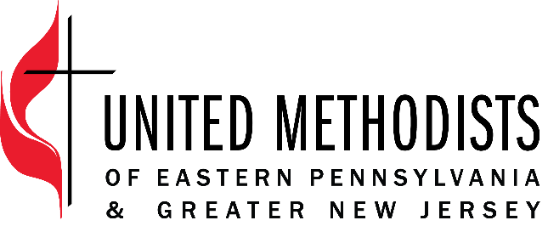

Title: Connectional Ministries Administrator
Classification: Full Time, Non-Exempt
Band Description: Administrative
Supervisor: Connectional Ministries Manager

EPA & GNJ employees, through their work help fulfill our mission: recruit and develop transformational leaders to make disciples and grow vital congregations to transform the world.
EPA & GNJ values as an organization and in its employees
- innovation and risk-taking
- excellence in its ministry and service
- compassionate and just service
- diversity
- collaboration

United Methodists of Eastern Pennsylvania & Greater New Jersey view all employees as leaders who are critical to the mission, capable of growth, and valued.

Position Summary
The Connectional Ministries Administrator resources the work of the Connectional Ministries team which develops resources and programs of EPA and GNJ. This position provides administrative support for the projects related to Connectional Ministries and Leadership Development so that activities are completed on time, accurately, and with excellence.

Essential Functions
- Support the Connectional Ministries Manager and team with administrative tasks including but not limited to the coordination of logistics, registration, and accommodations for events, trainings, workshops, and meetings so that radical hospitality is provided to clergy, laity, board/agency members and external training vendors and directors can provide excellent leadership development initiatives for laity and clergy.
- Provide support as needed for Grants and Scholarships.
- Provide coordination for Annual Conference Sessions
- Collaborate and support the work of Journey of Hope
- Process payment requests for the Connectional Table members.
- Provide support as needed for the Connectional Table members in preparing budget reports.
- Maintain electronic files and databases including Arena, EBridge, and internal drives so that all information is current, relevant, and accessible.

Organization Responsibilities
- Assist in maintaining calendars for meetings and appointments.
- Serve as a participant or as a project manager for projects as assigned
- Attend and assist in EPA & GNJ meetings and events as needed and appropriate
- Cover phones and provide hospitality at the reception desk as needed

Core Competencies
- Committed to continuously grow in intercultural competence
- Build and maintain relationships that are rooted in honesty, integrity and honor confidentiality
- Work cooperatively with others to produce innovative solutions.
- Communicate clearly and accurately, in writing and orally, with unifying messages that motivates people to action
- Utmost attention to details and deadlines
- Adapt to an ever-changing work environment so that tasks are carried out seamlessly
- Willingness to continually learn and develop skills
- Provide gracious hospitality

Qualification
- Highly proficient in Microsoft Office Suite and Adobe Acrobat
- Three or more years in an office or similar work environment
- Ability to navigate and learn various database systems

Education
- High School degree with some college or related experience

Travel
The position requires some evening and weekend responsibilities and some travel beyond the office.
The position works from the main offices located in Neptune, NJ and Norristown, PA in a hybrid model.

Employee Name:

Employee Signature: ___________________________________________________

Date: ___________________________________________

Supervisor Name:

Supervisor Signature: ___________________________________________________

Date: _________________________________

