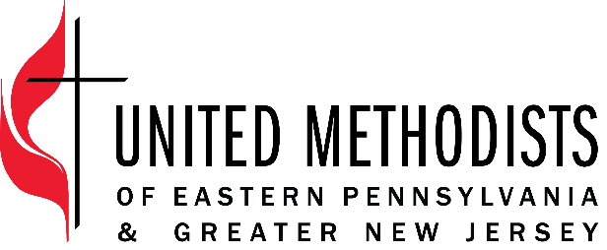

Title: Missional Data Specialist
Classification: Exempt
Band: Specialist
Supervisor: Missional Data Manager

EPA & GNJ employees through their work help fulfill our mission: recruit and develop transformational leaders to make disciples and grow vital congregations to transform the world.

EPA & GNJ values as an organization and in its employees
- innovation and risk taking
- excellence in its ministry and service
- compassionate and just service
- diversity
- collaboration

United Methodists of Eastern Pennsylvania & Greater New Jersey view all employees as leaders who are critical to the mission, capable of growth and valued.

Position Summary
The Missional Data Specialist works to improve the efficiency, accuracy, and usefulness of data and business systems for all departments and mission partners of EPA & GNJ by leading reporting initiatives, developing database tools, implementing system efficiencies, and creating a culture of data-driven decision-making. This position collaborates closely with the EPA & GNJ CFO’s and Missional Data Manager to provide expert data analysis to further the mission of EPA & GNJ, to make data more accessible to staff, clergy, and laity and to bring more automation to processes and procedures. This position collaborates with the Mission Data Administrator and external contractors/consultants as needed to ensure data needed for reporting is accurate, complete, and ready to use in reports.

Essential Functions
- Work with the Missional Data team to successfully complete development projects and reports on time so that EPA & GNJ leaders can effectively and efficiently carry out the mission.
- Work with the Missional Data Manager to identify/develop new reports and dashboards that will provide new insight for EPA & GNJ leaders so that staff, clergy, and laity may better understand their goals’ progress and challenges.
- Assist in creating innovative and efficient processes and procedures for business systems, reporting, and data collection, as well as train key staff on new processes and procedures so that EPA &GNJ ’s processes and procedures stay up to date amid changing environments and circumstances.
- Identify system improvements in consultation with other departments and work with Missional Data team to implement so that EPA & GNJ leaders spend more time on the mission rather than administrative work.
- Lead efforts related to compiling reports so that EPA & GNJ and their vital mission partners have the reports needed for staff, clergy, and laity to make data driven decisions.
- Liaison with GCFA (General Council of Finance and Administration). KFS (Kingdom First Solutions), and contracted programmers to move forward updates and changes in the database and monitor market changes and opportunities for conference data systems.
- Complete technical briefs for systems development projects and serve as the main point of contact for contractors so that contractors are well equipped to develop system tools.
- Provide technical support and guidance to staff, laity, and clergy when questions or issues arise with using system tools; resolve as quickly as possible.

Organization Responsibilities
- Participate in Missional Development team meetings
- Serve as a participant or as a project manager for projects as assigned
- Attend and assist in EPA & GNJ meetings and events as needed

Core Competencies
- Committed to continuously grow in intercultural competence
- Build and maintain relationships that are rooted in honesty, integrity, and honor confidentiality
- Work cooperatively with others to produce innovative solutions.
- Communicate clearly and accurately, in writing and orally, with unifying messages that motivates people to action
- Adapt to an ever-changing work environment so that tasks are carried out seamlessly
- Attend to details and deadlines
- Quickly master new system tools and applications
- Understand complex systems, data compilation, and data manipulation
- Provide excellent service and support so that others feel equipped and empowered

Qualification
- Three or more years of experience in information systems and data management
- Understanding of SQL databases and programming
- Competent and skilled in SQL, HTML, Microsoft Office Suite, Adobe Acrobat, and project management software

Education
- Bachelor’s Degree or related experience

Travel
The position requires occasional evening and weekend responsibilities. The position works in a hybrid model from the main office located in Neptune, NJ.

Employee Name: ___________________________________________________

Employee Signature: ___________________________________________________

Date: _________________________________

Supervisor Name: ____________________________________________________

Supervisor Signature: ___________________________________________________

Date: _________________________________

